OOPJ ASSIGNMENT 13
Name – Venya Kejriwal
Roll Number – 24155517
- Life Cycle of Thread
class LifeCycleThread extends Thread {
public void run() {
System.out.println("Thread is running...");
}}
class ThreadLifeCycleDemo {
public static void main(String[] args) throws InterruptedException {
LifeCycleThread t = new LifeCycleThread();
System.out.println("State after creation: " + t.getState());
t.start();
System.out.println("State after start(): " + t.getState());
t.join();
System.out.println("State after completion: " + t.getState());
System.out.println("VENYA KEJRIWAL - 24155517");
}}
OUTPUT
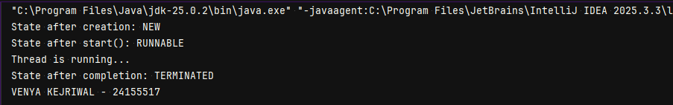
- Synchronized Method Using Anonymous Class
class syn {
int count = 0;
synchronized void increment() {
count++;
System.out.println("Count: " + count);
}}
class SynchronizedThreadDemo {
public static void main(String[] args) {
syn c = new syn();
new Thread() {
public void run() {
for (int i = 0; i < 5; i++) {
c.increment();
}}}.start();
System.out.println("VENYA KEJRIWAL - 24155517");
}}
OUTPUT
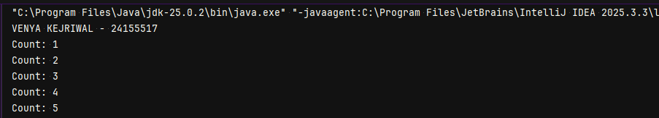
- Static Synchronized Block
class StaticCounter {
static int count = 0;
static synchronized void increment() {
count++;
System.out.println("Static Count: " + count);
}}
class StaticSyncDemo {
public static void main(String[] args) {
new Thread() {
public void run() {
for (int i = 0; i < 5; i++) {
StaticCounter.increment();
}}}.start();
System.out.println("VENYA KEJRIWAL - 24155517");
}}
OUTPUT
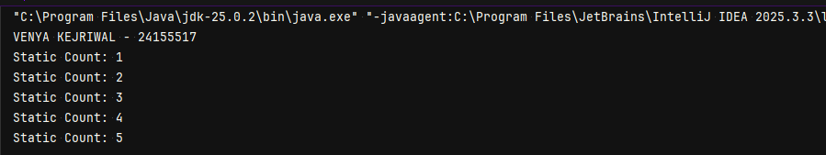
- Deadlock
class DeadlockExample {
public static void main(String[] args) {
final Object lock1 = new Object();
final Object lock2 = new Object();
new Thread() {
public void run() {
synchronized(lock1) {
try { Thread.sleep(50); } catch(Exception e) {}
synchronized(lock2) {
System.out.println("Thread 1 finished");
}}}}.start();
new Thread() {
public void run() {
synchronized(lock2) {
try { Thread.sleep(50); } catch(Exception e) {}
synchronized(lock1) {
System.out.println("Thread 2 finished");
}}}}.start();
System.out.println("VENYA KEJRIWAL - 24155517");
}}
OUTPUT
- Deadlock Avoiding
class NoDeadlockExample {
public static void main(String[] args) {
final Object lock1 = new Object();
final Object lock2 = new Object();
new Thread() {
public void run() {
synchronized(lock1) {
try { Thread.sleep(50); } catch(Exception e) {}
synchronized(lock2) {
System.out.println("Thread 1 finished safely");
}}}}.start();
new Thread() {
public void run() {
synchronized(lock1) { // same order
try { Thread.sleep(50); } catch(Exception e) {}
synchronized(lock2) {
System.out.println("Thread 2 finished safely");
}}}}.start();
System.out.println("VENYA KEJRIWAL - 24155517");
}}
OUTPUT
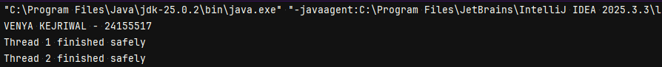
- Interrupted Thread Code
class inter extends Thread {
public void run() {
for(int i=1;i<=5;i++){
System.out.println("Count: " + i);
try {
Thread.sleep(1000);
} catch (InterruptedException e) {
System.out.println("Thread interrupted but continues...");
}}
System.out.println("Thread finished normally");
}}
public class InterruptDemo {
public static void main(String[] args){
inter t = new inter();
t.start();
try { Thread.sleep(2000); } catch(Exception e) {}
t.interrupt();
System.out.println("VENYA KEJRIWAL - 24155517");
}}
OUTPUT
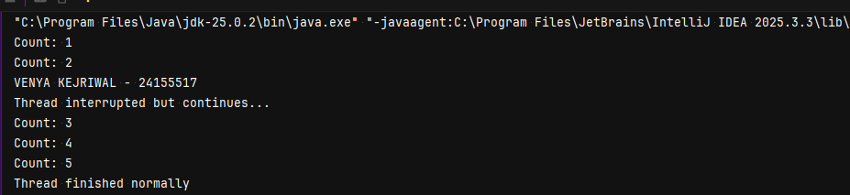
- Is Interrupt Thread
class CheckInterrupt extends Thread {
public void run() {
for(int i=1;i<=5;i++){
System.out.println("Count: " + i);
if(isInterrupted()) {
System.out.println("Detected interrupt using isInterrupted()");
}
try { Thread.sleep(1000); }
catch(InterruptedException e) {
System.out.println("InterruptedException caught");
System.out.println("Thread interrupted status using interrupted(): " + Thread.interrupted());}}}}
class InterruptCheckDemo {
public static void main(String[] args){
CheckInterrupt t = new CheckInterrupt();
t.start();
try { Thread.sleep(2500); } catch(Exception e) {}
t.interrupt();
}}
OUTPUT
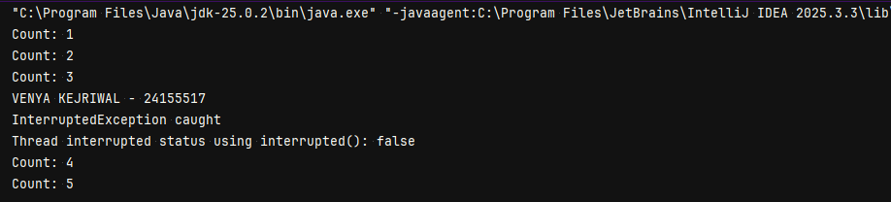s

